Mod-6 Journal: Explore Object-Oriented Programming
Mary Gerdes
CS 500: Introduction to Programming
Southern New Hampshire University
March 12, 2026
Mr. Omar Hamdy

Mod-6 Journal: Explore Object-Oriented Programming

Introduction
Object-oriented programming (OOP) is a foundational approach to modern software development that organizes code around objects and data rather than solely around functions. In Python, OOP helps developers to design modular, reusable, and scalable applications using principles such as classes, objects, inheritance, encapsulation, and polymorphism (Amos, 2023). This is valuable especially in complex systems where structure and maintainability are needed.
This journal explores OOP through the application of game design. Video games naturally consist of interacting entities, including players, enemies, items, and environments, which have distinct attributes and behaviors. Game development provides a practical and clear example of how OOP principles support organized and efficient program design.

Practical Application:
I chose game design as it clearly demonstrates how real-world entities can be represented as software objects. In a classic role-playing game (RPG), there could be a player, multiple enemy types, weapons, and leveling. Each entity has properties such as health or position, and behaviors such as moving or attacking.
OOP allows developers to model these entities as classes, which serve as a blueprint for creating objects. This is an important structure for games that frequently adds new characters and features. Having a well-designed object-oriented system ensures the game is scalable and manageable as it grows in complexity.

Key OOP Concepts
Classes and Objects:
A class is a custom-defined data type that bundles related data and behavior together, while an object is an instance of that class (W3Schools, 2019). For example, a Character class in a game might define attributes such as name and health, along with methods to move. So, when a player is created, it becomes an instance (object) of the character class, as shown in Figure 1. This allows developers to create multiple characters from a single template, reducing redundancy and improving organization.
Inheritance:
Inheritance allows one class to derive from another, allowing it to gain its attributes and methods. In a game, both the player and enemy classes may inherit from a base character (See Figure 2). This means code doesn’t have to be rewritten for shared functionality such as movement or health, reducing redundancy. Inheritance creates a logical hierarchy and supports code reuse. If a new character type is introduced, the base class can be extended without altering the existing code.
Encapsulation:
Encapsulation refers to bundling data and methods within a class while limiting direct access to certain internal details. In Python, prefixing an attribute with an underscore indicates that it should not be accessed directly (Python Software Foundation, 2019). In a game, a character’s health should not be arbitrarily modified. Instead, using a controlled method like take_damage() manages changes safely (See Figure 3). This method protects the program's integrity by preventing unintended interference with critical data and reducing bugs.
Polymorphism:
Polymorphism allows different classes to use methods with the same name but different behaviors. For instance, both player and enemy may define an attack method, even though each performs a different action (See Figure 4). This allows the game engine to call attach() on any character object without knowing its exact type. This method promotes simplification and flexibility in the code by letting generalized functions interact with multiple object types seamlessly.

Benefits of OOP
For the end user, OOP results in a more stable and expandable gaming experience. Encapsulation reduces unexpected errors, while inheritance and polymorphism allow developers to introduce new characters and features without disrupting existing gameplay, making updates and performance smoother. For the developer, OOP improves collaboration and code organization. Classes group related logic, making programs easier to read and maintain. Additionally, inheritance reduces duplication, and polymorphism allows for flexible, reusable functions. OOP promotes a modular structure, organizing code into self-contained units. This simplifies testing, debugging, and scaling. Although it doesn’t guarantee faster execution, its structured design makes optimization and long-term maintenance more efficient.

Conclusion
Object-oriented programming is essential in modern Python development, particularly with complex applications like game design. Real-world entities are modeled through classes and objects with inheritance promoting reuse and scalability, encapsulation protecting data integrity, and polymorphism allowing flexibility. In game development, these principles create organized, maintainable, and expandable systems that benefit both developers and users.
References
Amos, D. (2023, September 11). Object-Oriented programming (OOP) in python 3 – real python. Realpython.com. https://realpython.com/python3-object-oriented-programming/
Python Software Foundation. (2019). The Python Language Reference — Python 3.8.0 documentation. Python.org. https://docs.python.org/3/reference/
W3Schools. (2019). Python Classes. W3schools.com. https://www.w3schools.com/python/python_classes.asp

Figures
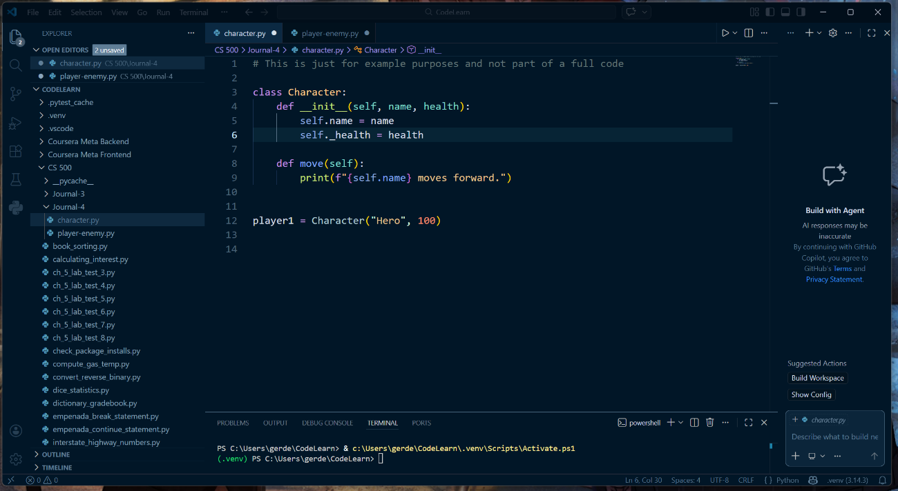
Figure 1 Class-Object Example

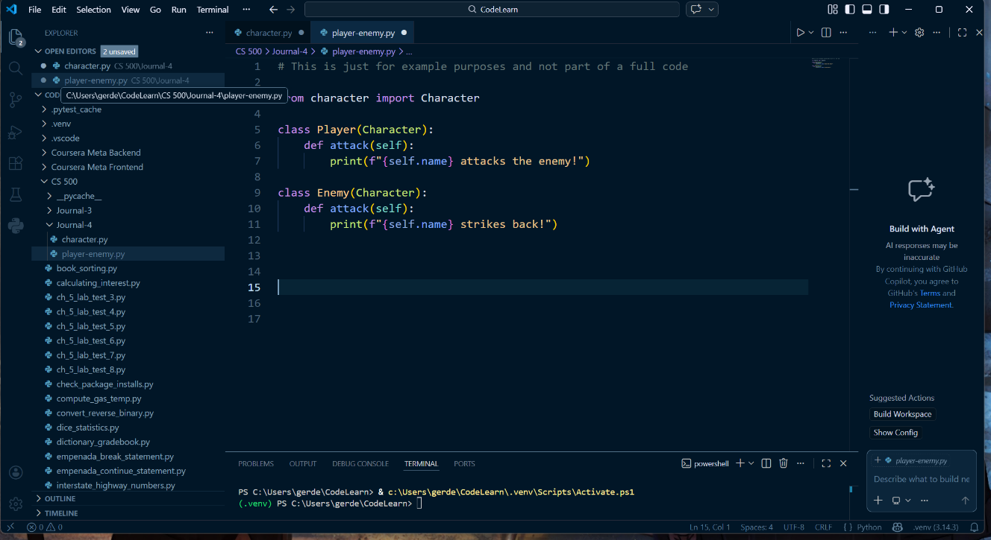
Figure 2 Player-Enemy Inheritance Example
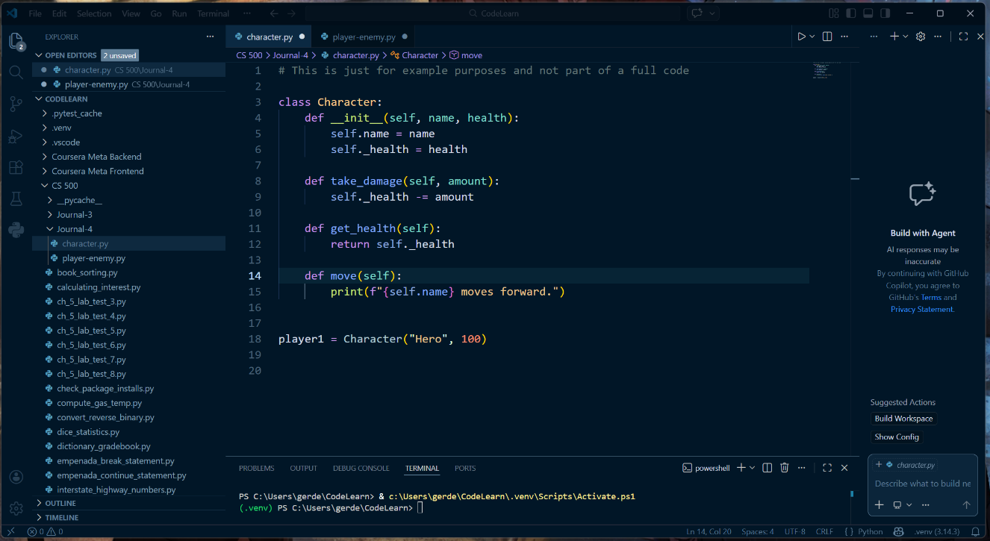
Figure 3 Encapsulation Example

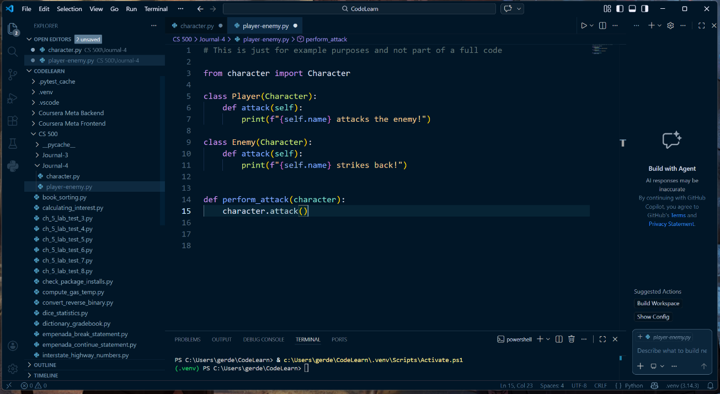
Figure 4 Polymorphism Example

